**Group No: 3**

**Members: 1. Abu Sinha Md. Sala Uddin (152-15-5581)**

**2. Saima Afrin (152-15-5905)**

**3. Tanjid Ibna Akid (152-15-5861)**

**4. Asma Rahman Meem (152-15-5757)**

**Project Name: Text Editor**

*A text editor is a type of program for editing plain text files including of having various option like saving, coping etc. We had tried to make such kind of project.*

**Operations:**

For this project we needed to use the java build in packages to get the access of the necessary classes and methods from those packages.

First, we import Java “AWT” and “Swing” packages. Our created class “Ali” extends the JFrame class which is a class of swing package and also implements the “Action Listener” interface.

Then, we use the build in classes named JTextArea, JMenuBar, JMenuItem, JToolBar etc.

For the new option of the editor we accessed the following method: fileM, editM, fontM, styleM, exitI, cutI, copyI, pasteI, selectI etc.

From JFrame class, we use setSize(). setLocationRelativeTo(), setDefaultCloseOperation() methods to set the different operation to set our basic editing frame.

Then we arranged and decorized the menuitems on the menubar with the “add()” method.

We use “EventListener” to get access on the keyboard shortcut options.

We create and declare objects for every used classes as well as the methods.

After that we use “ActionListener” interface on every method with “ActionPerformed()” method which is the one and only method of the “ActionListener” interface. We declare the performance according to the user choice using the “if else” condition.

At last in the “main” class we just called our created class “Ali()”.

**Source Code:**

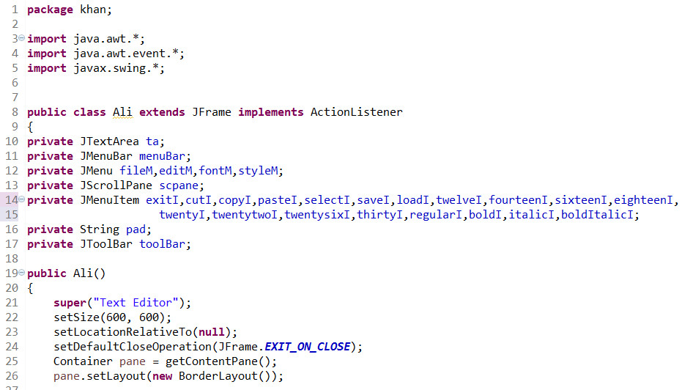

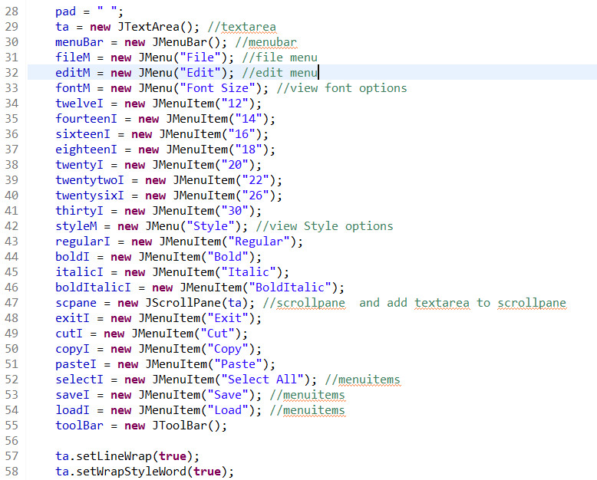

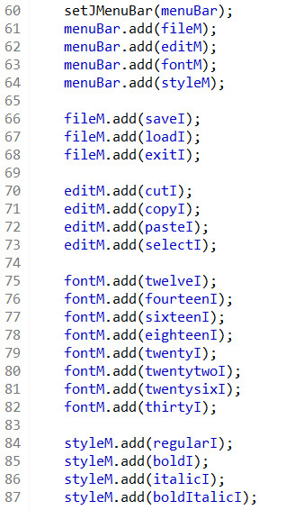

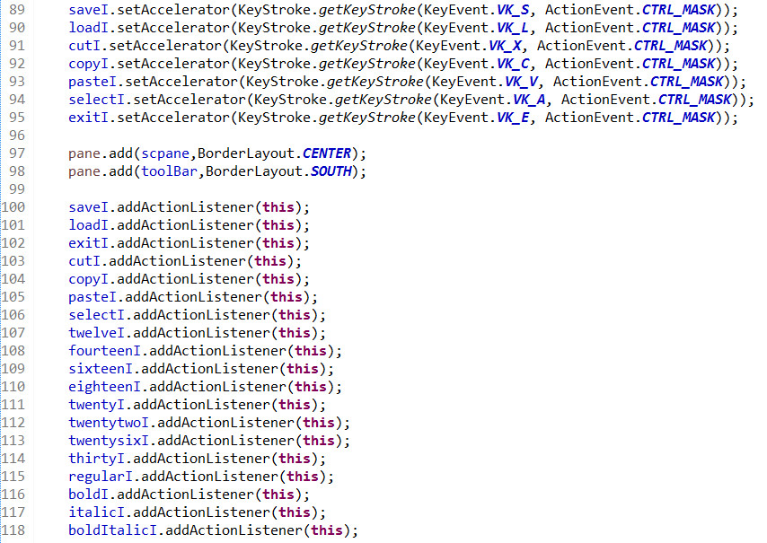

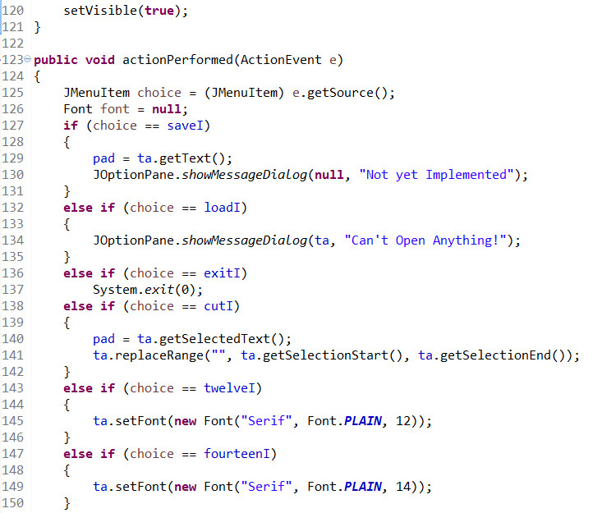

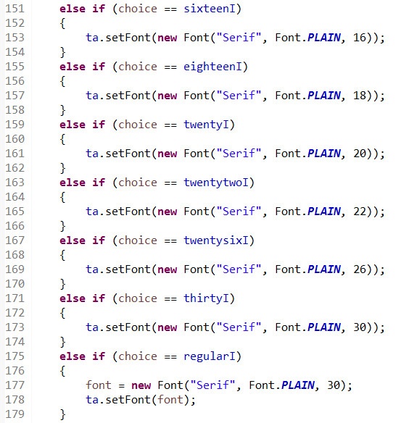

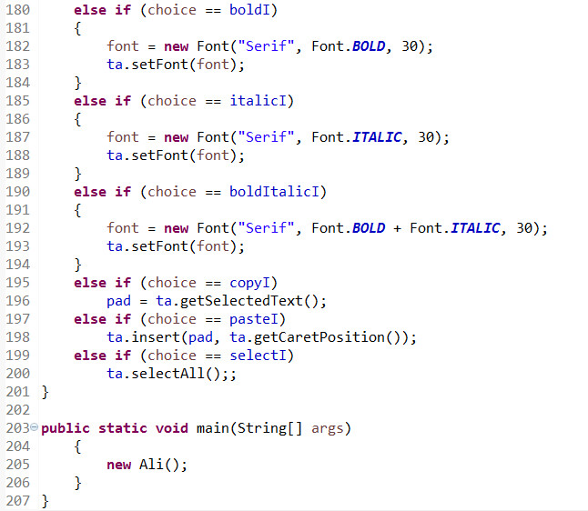

***Output:***

